AN UNFORGOTTEN ROUND-TRIP IN THE NATURAL PARKS OF

DANUBE – NERA-CARAS MICROREGION
An ecotourism program destined of promoting of the natural, history and cultural patrimonies from the park areas of Porţile de Fier (Iron Gates) Cheile Nerei – Beuşniţa (Nera – Beusniţa Gorges), Vršačke Planine (Vrsac Mountain Range) and Deliblatska Pesčara (Deliblato Sands).

Our Story
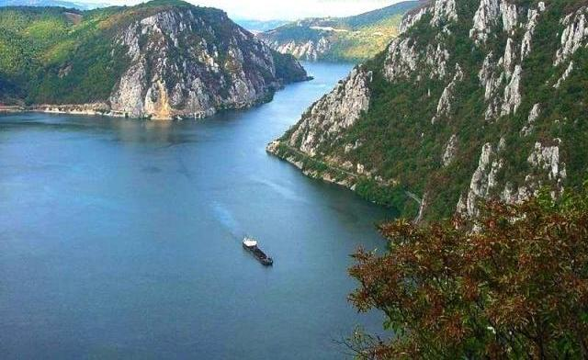
How will you like to be a witness of a great nature work? By giving as the chance to show you the Iron Gates area, we have no doubt that you will experience a great vacation and great information about a very special area. So what makes this area so different? The tumultuous Danube River was assaulting the mountains over the years, and great places came out of it. That’s how The Iron Gates came into being- the triumphal arch through which the new river came into the Universe.
Danube Gorges
This river, both agitated and blue, impetuous and calm, dull and musical didn’t exist until the Iron Gates existed.
The drama of its genesis couldn’t have occurred anywhere else but here, in this place that carries the mark of the first spasms. The rock is painfully striated like in the birth struggle.
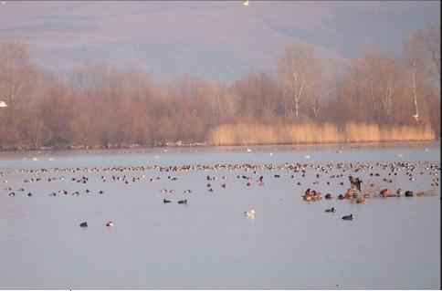
Until the Iron Gates Weir/Barrage appeared, the waters of the Danube collected between the mountains, tenaciously stroked against the rapids, were regaining the primal scream with which the river came to life. Once in a while, through the terrible passage continues to blow, even today, the Cosava wind, like an embodiment of some forces designed for a world with other dimensions, Cyclops-like and violent.
Nera - Danube river junction, a world of egrets and cormorants
The sight of the Iron Gates involves, regarding the elements, the iron and the colossal rock that became a mountain. This is a mountain that is in permanent battle with the water, but also in harmony with it.
The Geometric Mountain.
At a millenary scale, though, the Gates are some Historical Replica’s of what????. Everything around is silence and stillness.
The great dimensions of the Cosmos are present here- the Infinity and the Eternity.
Our team is ready and well prepared to present all those extraordinary places to our future tourist. We are really eager to shear with them our love towards nature’s miracles.

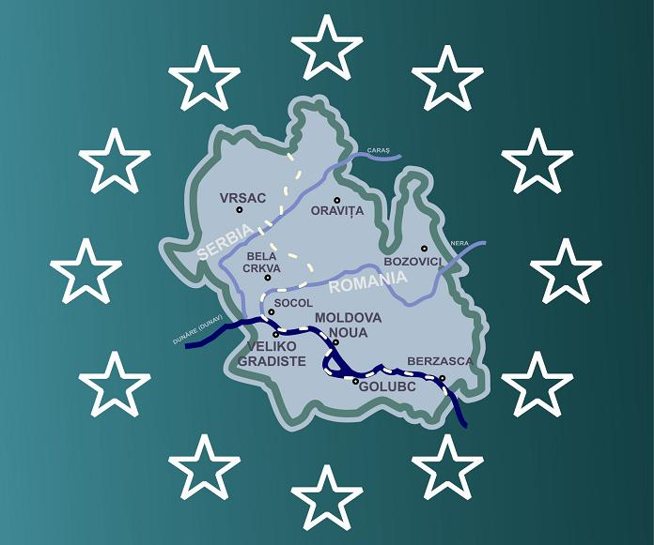
First day’s Schedule
Cross border cooperation micro region
of Danube – Nera – Caras

Danube-Nera-Caras micro region greets their guests.
(Flexible program in according with the guest arrivals)

Our ecotourism program could start at Oravita, Vršac, Bela Crkva or Moldova Nouă, because any of these localities are placed in the area of a natural park from Danube-Nera-Caras (DNC) micro region, on a trunk road. The tourists could come by plane to Timisoara or Belgrad airports. From there they could continue their travel, by bus or riding a bike, to the ecotourism destinations.
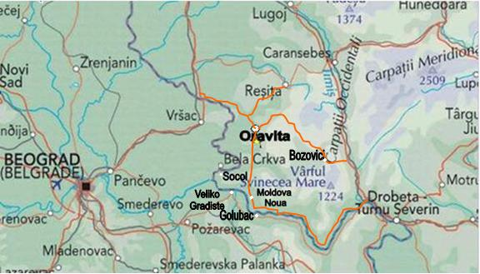
We offer you a version of the ecotourism program, having Oravita City as a start place.
Access toward the Danube-Nera-Caras micro region

In the first, morning at Oravita’s Ecological Informing Center our tourists will be introduced to the following:

A General Presentation of the Natural Protected Areas at the Border zone of DNC Micro Region.

● The mirific world of Danube-Nera-Caras micro region – documentary film.

● Biodiversity of the natural protected areas from Danube – Nera - Caras micro region –Power Point presentation

●Delivering to the tourist group of printed promotional materials (leaflets, brochures)

Riding a bike (or travel by bus) to Sasca Montană village at length of 1h 30’’, will make our tourists come in contact with beautiful places.

In the enigmatic natural reserve of Susara Valley.
Walking on the forest path with a lenghtwise of 5 Km, and having a max slope of 32% our tourists have an access on the left, at the exit from Sasca Montana village toward Carbunari village.
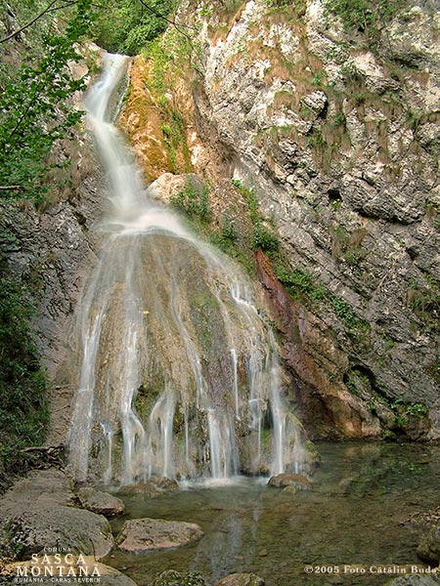
Objectives:
Susara cascade
Identifying and presentation of specific biodiversity:
● Forests of Corylus colurna, Podus mahaleb, Jugleus regia, Rosa stylosa var beucensis, Taxus baccata, Fraxinus ornus, cărpiniţă Carpinus orientalix, Ruscus aculeatus, Ruscus hypoglosum), Iris graminea, Peonia tenuifolia var triternatifolia, Gladiolus illiricus, Dianthus banaticus, Peonia officinalis var banatica.
● Exemplars of Ursus Arctos, Lynx lynx, Neophran perenopterus, Apus melba, Hirunda rupestris, Hirunda daurica, Oenanthe hispanica, Emberiza cirulus, Vipera amodytes, Anguis fragilis colticus, Euscarpius carpathicus, Rhinolopus luryale.
-Walking to Şuşara cascade, Water Cave, Sand Cave.
- Traditional holidays (nedeea) of Sasca Montană village (29th of Jun ) and Carbunari village (15th of August)

Accommodation and diner in the area of Nera Gorges – Beusnita National Park (NGBNP)

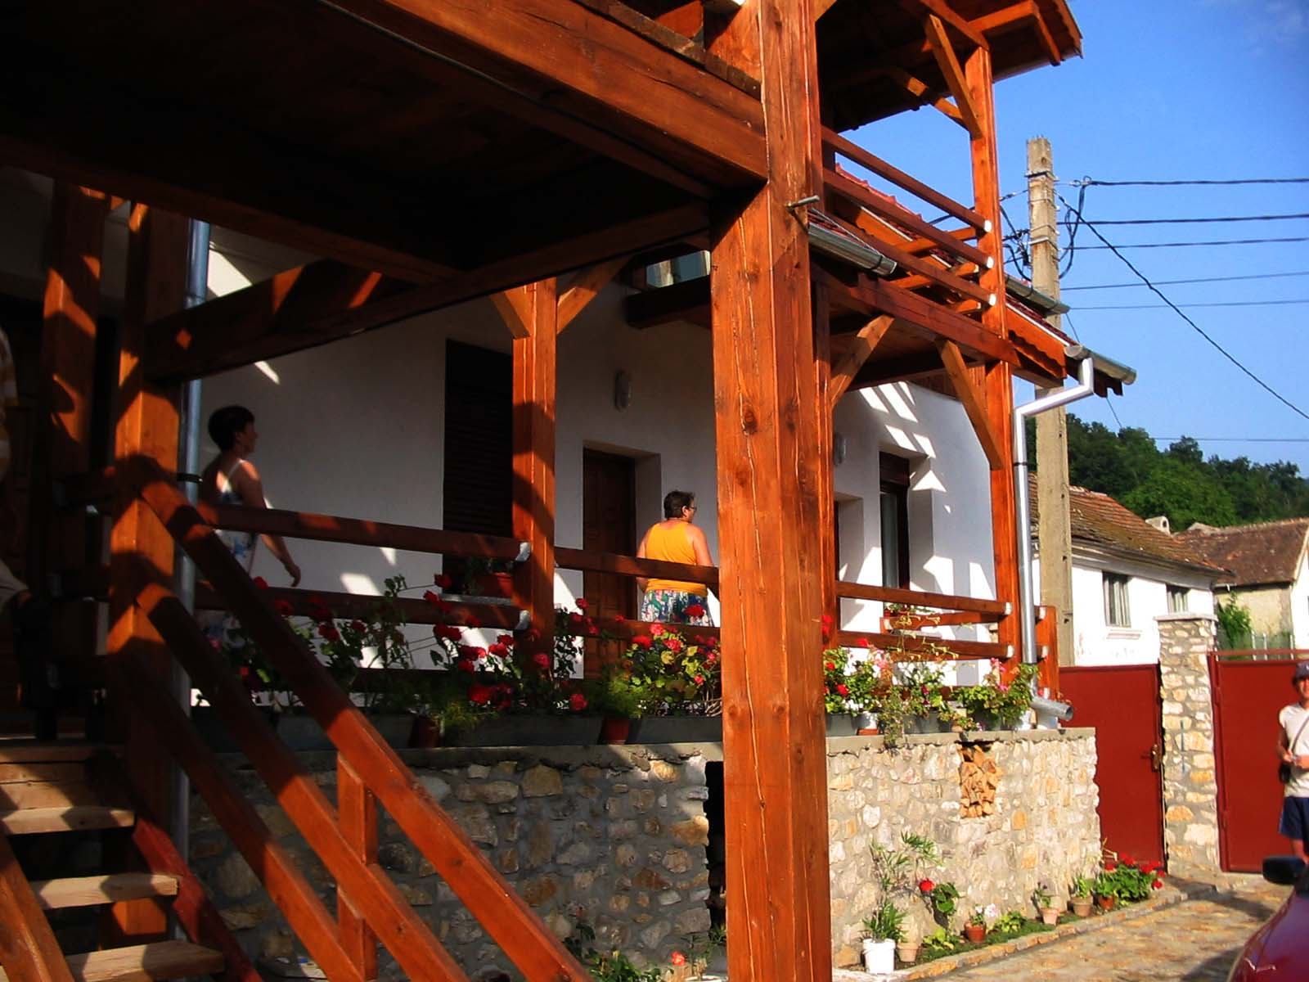
DORA Tourism Guesthouse
(Sasca Montana)
♣♣

Access: at the left from the main road coming from Oravita, at the enter in Sasca Montana village.
Tourism offer: 29 accommodation places, bar, restaurant with terrace, riding a bike, pool, ecotourism authorized guide, Banat traditional menu.

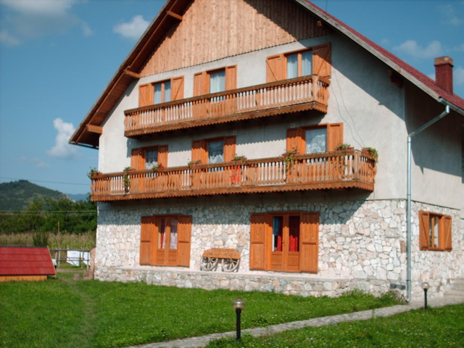
CHEILE NEREI Tourism Guesthouse
(Sasca Romana)
♣♣♣

Access: at the left from the main road coming from Sasca Montana, at the enter in Sasca Romana village.
Tourism offer: 28 accommodation places, parking, bar, restaurant with terrace, riding a bike, paintball, pool, rafting, riding, ecotourism authorized guide, Banat traditional menu.
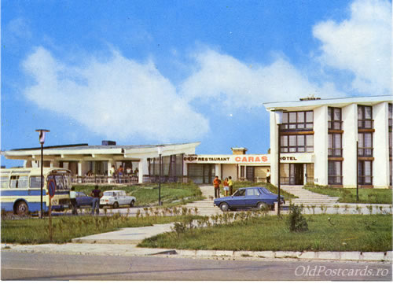

CARAŞ Hotel
(Oraviţa)

Access: at the left from the national road coming from Timisoara, at the enter in Oravita city.
Tourism offer: 40 accommodation places, parking, bar, restaurant with terrace, Banat traditional menu.
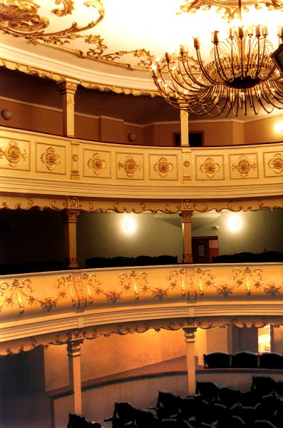
Second day’s schedule
Oravita Theatre

Mirific world of Beusnita Cascade and Ochiu Bei (Bei Eye) areas

8:30 – 9:30

Breakfast at the accommodation places from NGBNP area

10:00 – 12:30
ORAVITA, a live history of Romaian premieres. Tour of Oravita city and Ciclova Montana village.
Objectives
-Cultural – historic premieres such as Mihai Eminescu Theatre – the oldest theatre from Romania, Knoblau Farmacy Museum, two dams on Oraviţa River – the oldest riprap dams from Romania, orthodox Cathedral, Catholic Church, Oravita railway station and Oravita – Bazias railway – the oldest railway from Romania.
- Identifying and presentation of specific biodiversity of Valea Ciclovei (Ciclova Valley) natural reserve
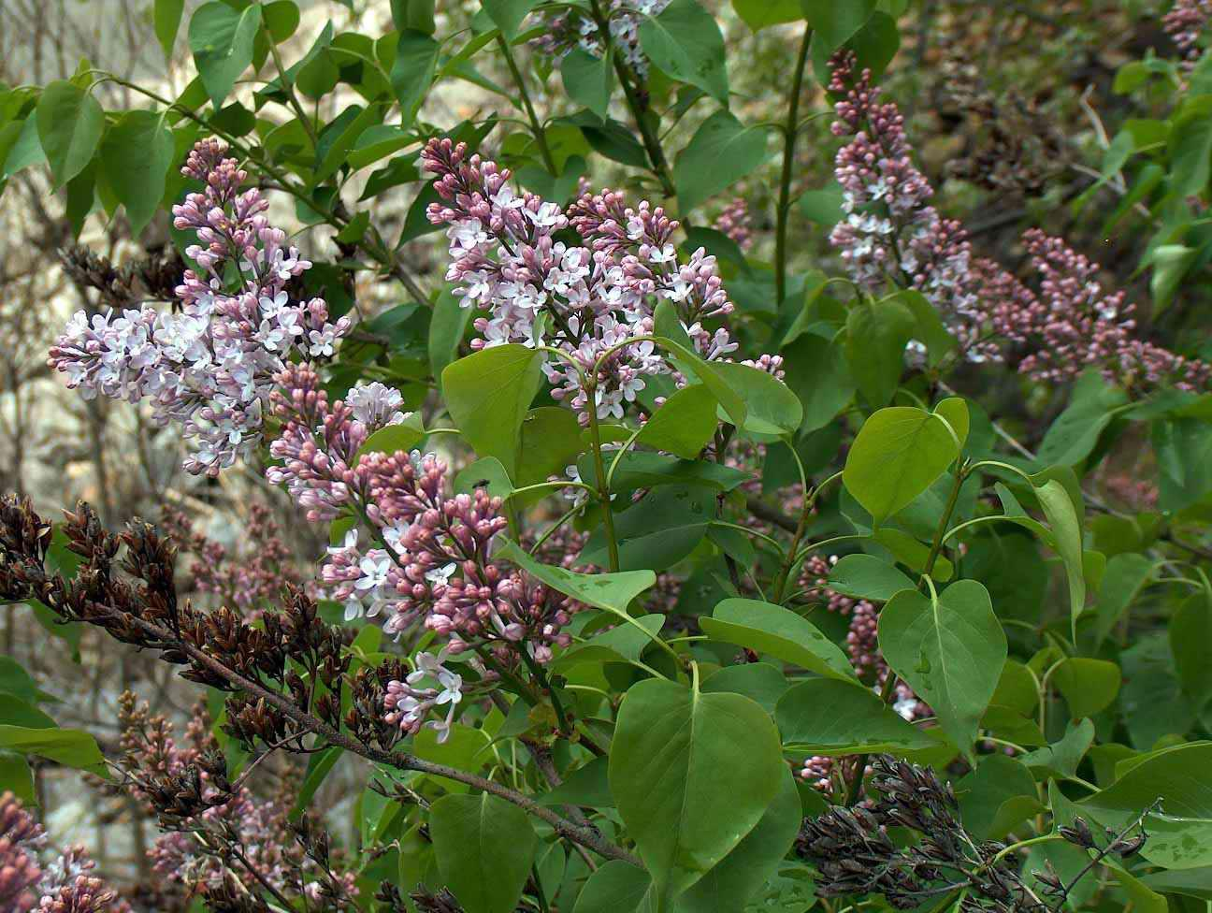
● Forests of Corylus colurna, Podus mahaleb, Jugleus regia, Taxus baccata, Syringa vulgaris, Fraxinus ornus, Carpinus orientalix, Ruscus aculeatus, Peonia mascula var triternotifolia, Ruscus hypoglosum, Iris graminea.
Syringa vulgaris
● Exemplars of Lynx Lynx, Ursus Arctos, Emberiza Cirulus, Vipera Ammodytes.
- Walking to Piatra Simionului (Simion Stone), Piatra Rolului (Rol Stone), Pestera Sf. Elena (Saint Elena cave), Calugara monastery

12:30 – 14:00
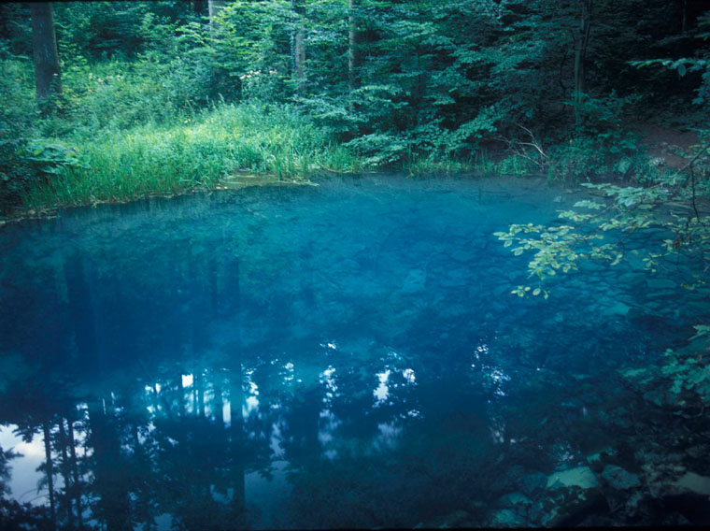
Riding a bike (or travel by bus), on the run of Oraviţa – Ciuchici – Potoc – Podul Beiului (Bei bridge) – cantonul silvic Valea Beiului (Bei Valley forest district) on the distance of 20 Km (with 8 Km of forest no rehabilitated road, having max. slope of 30%).
Ochiu Bei
(Bei eye)

14:00 – 15:30
Lunch at Valea Beiului (Bei Valley) trout farm

15:30 – 18:00
Bei Valley and Beusnita Cascades nature reserve. Walking on the forest path, lenghtwise of 5 Km, having max. slope of 38 %, with the access from Bei Valley forest district.
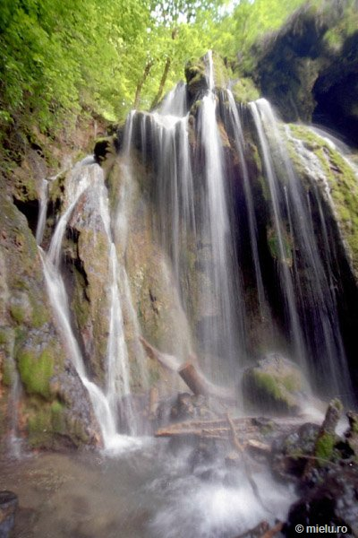
Objectives
Beuşniţa Casccade
- Identifying and presentation of specific biodiversity of Cascadele Beusnita (Beusnita Cascades) nature reserve
● Forests of Corylus colurna, Taxus baccata, Syringa vulgaris, Fraxinus ornus, Cornus mas, Carpinus orientalis, Cotinus coggygria.
● Nature monuments as Rosa Stylosa Desv. var. Beucensis, Padus mahaleb, Ruscus aculeatus, Ruscus hypoglosium, Gladiolus illyriscus
● Walking to Cascadeole Beusnita (Beusnita Cascades), Ochiu Bei (Bei eye) spring, Bei Valley
- Traditional holidays (nedeea) of Oravita city (20 July) and of Ciclova Romana village (15 August).

18:00 – 19:30
Return to accomodation places

20:00
Banat traditional menu diner and folk show at Dora and Cheile Nerei tourism guesthouse including traditional sings, dances from Nera Valley and Caras Valley areas.

Third day’s Schedule

Trip at Vrsac Mountains Range

8:30 – 9:30

Breakfast at the accommodation places from NGBNP area

10:00 – 12:00
Riding a bike (or travel by bus), on the run of Oraviţa (Sasca – Montană) – frontier station Naidas / Kaluđerovo – Bela Crkva – Vrsac, on the distance of 55 Km

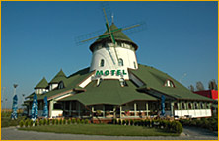
12:00 – 13:00

Accommodation and refreshment at the locations from the area of Vrsac Mountains Natural Park (VMNP)

VETRENJAČA Motel

Tourism offer: 16 accommodation places, parking, bar, restaurant with terrace, Banat traditional menu.

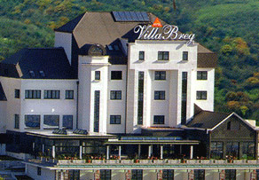
VILA BREG Hotel

Tourism offer: 150 accommodation places, parking, bar, bowling, swimming pool, conference room, electronic games, restaurant with terrace, Banat traditional menu.

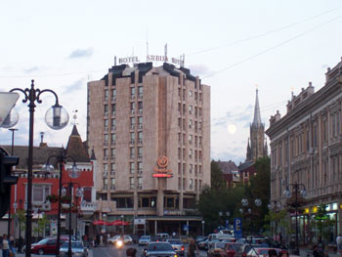

SRBIJA Hotel

Tourism offer: 186 accommodation places, parking, bar, bowling, conference room, restaurant with terrace, Banat traditional menu.

13:00 –14:00
Lunch at the accommodation places from VMNP area

14:00 –14,;0
Riding a bike (or travel by bus), on the run of Vrsac – Vrsac Mountine Range (Vršačke Planine)
Natural Park on the distance of 4 Km having max. slope of 35%.

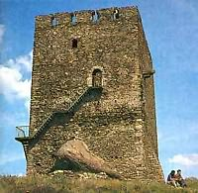
14:30 – 19:00
Vrsac fortress (Kula) ruins
Trip toward the Gudurica Pick. The forest path has a lenghtwise of 7 Km, having max slope of 45 %. The accession on the left is from the road Vrsac – Kustilj, at the exit from Vrsac city.

Objectives
- Identifying and presentation of specific biodiversity of Vrsac Mountains Range Natural Park
● Forests of Quercus robur, Tilia cordata, Robinia pseudocacia, Fagus silvatica, Acer pseudoplatanus, Pinus nigra
● Exemplars of Sus scrofa, Lepus europeus, Canis lupus, vulpes, Felis silvestris, Meles meles, Mustela putoris, Syrmaticus reevesi, Alectoris graeca, Coturnix coturnix, Streptopelia turtur, Columba livia, Scolopax rusticola, Athene noctua, Corvus corax, Garrulus glandarius
Vrsac cultural historic objectives such as: Vrsac Fortress (Kula ) ruins , Episcopal palace, Saint Nicholas orthodox church , Saint Gerhard catholic church, Iovan Sterie memorial house, Vrsac city museum, Jovan Sterije Popovic National Theatre , Pharmacy on the stairs galleries, Vrsac downtown, Centrul Millennium Centar, Vrsac airport, Vrsac Lake, Vrsac vineyard, Mesic monastery, Grape Ball - traditional holiday of Vrsac city (September)

19:00
Banat traditional diner and Serb folk show including sings and dances at VETRENJAČA Motel
.
Fourth day’s Schedule

In Deliblato Sands nature reserve, at the winds crossroad

8:30 – 9:30

Breakfast at the accommodation places from VMNP area

9:30 – 10:30
Riding a bike (or travel by bus), on the run of Vrsac – Jasenovo - Grebenac on the distance of 40 Km

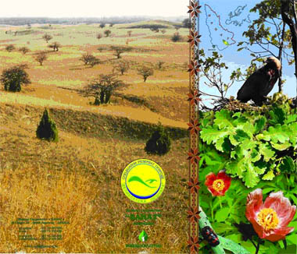
10:30 – 13:00
Deliblato Sands
By the schooner in Deliblato Sands. The trip takes place over 12 Km into Deliblato Sands nature reserve.
Objectives
- Identifying and presentation of specific biodiversity of Deliblato Sands nature reserve
● Forests and prairie areas including exemplars of Paeonia Officinalis Subsp, Rhus Continus, Fritillaria Degeniana, Artemisia Pancicii, Rindera Umbelata, Echinops Banaticus, Tenuifolia, Adonis Vernalis
● Exemplars of the fauna such as Podarcis Taurica, Coluber Caspius, Lacerta Viridis, Pelobates Syriacus) , Falko Cherrug, Aquila Heliaca, Aquila pomarina, Pernis apivorus, Burchinus oedicnemus, Phalacrocorax pygmaeus, Riparia riparia, Sicista subtilis, Spalax leucodon, Scirius citelus, Myotis emarginatus, Canis canis, Linx linx.

13:00 – 13:30
Riding a bike (or travel by bus), on the run of Grebenac – Bela Crkva, on the distance of 15 Km

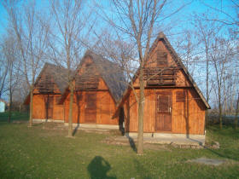
13:30 – 15:00
The lunch will be hold at the accommodation places from the area of Deliblato Sands natural reserve (DSNR)

OAZA tourism lodges

Tourism offer: 30 accommodation places, parking,

LAGUNA Tourism Guesthouse
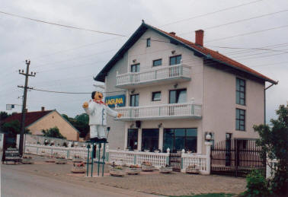
♣♣♣

Tourism offer: 12 accommodation places, parking, bar, restaurant with terrace, boating, nautical ski, Banat traditional menu.

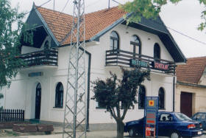
SOKOLAC Tourism Guesthouse
♣♣♣

Tourism offer: 12 accommodation places, parking, bar, restaurant with terrace, boating, nautical ski, Banat traditional menu.

15,00 – 15,30
Riding a bike (or travel by bus), on the run of Bela Crkva – Banatska Palanka - Stara Palanka, on the distance of 12 Km

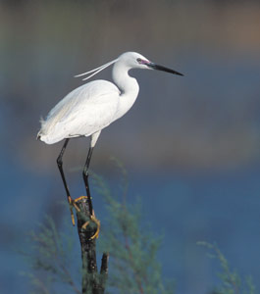
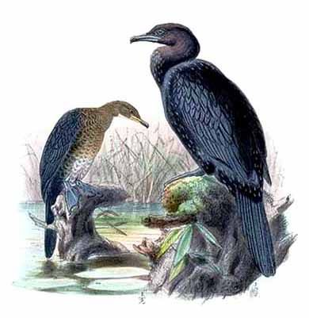
15:30 – 19:00
Egretta garzetta
Phalacrocorax
pygmeus
Labudovo Okno Water dreamland. The trip takes place on the tourism path, of Danube’s bank with a lengthwise of 5 Km, into Labudovo Okno dump area (Ramsar site), with the access from Stara Palanka village.
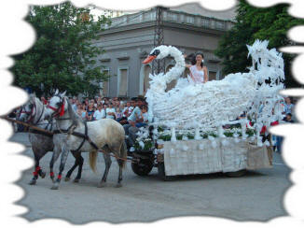
There will be hold the process of identifying and presentation of fauna exemplars of the protected species such as: Silurus glanis, Stizostedion lucioperca, Acipenser ruthenus), Phalacrocorax pygmaeus, egretta garzetta, Anser albifrons, Bucephala clangula.
Bela Crkva Carnaval
Some tourism attractions such as Ram fortress ruins, travel across the Danube by ferryboat, the Danube – Tisa – Danube Kanal, sport fishing , nautical ski, and Bela Crkva Carnaval (in August) are absolutely a must to experience by our tourists.

19:00
At this time, will take place the Banat traditional diner and Serb folk show, including sings and dances in Stara Palanka village.
Overall, we are absolutly shoure that our future tourists will have an enjoible and educative trip while spending their time at any of those beautifull location. We will go above and beyond to make shoure that their trip will be an unforgetable experience so they will consider to come back and visit us again.
Return to the accomodation places

Fifth day’s Schedule

Upstream area of Danube Gorges

8,30 – 9,30

Breakfast at the accommodation places from DSNR area

9,30 – 11,00
Riding a bike (or travel by bus), at lengthwise of 45 – 60 Km, on the run of Bela Crkva) – frontier station Kaluđerovo / Naidas –– accommodation location from Upstream area of Danube Gorges (Radimna, Moldova Noua, Bazias)

11, 00 – 12, 00 Accommodation and refreshment at the locations from the area of Iron Gate Natural Park (IGNP)

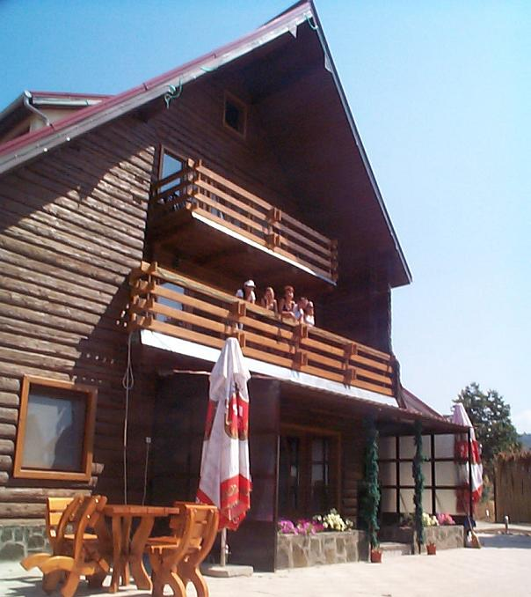

DUNAREA Tourism Guesthouse
(Moldova Nouă)
♣♣
Access: You can get in by making a left from the national road coming from Pojejena, immediately after entering the Moldova Noua City.
Tourism offer: 19 accommodation places, parking, bar, restaurant with terrace, traditional fish menu, folk show including sings and dances from Danube Gorges area

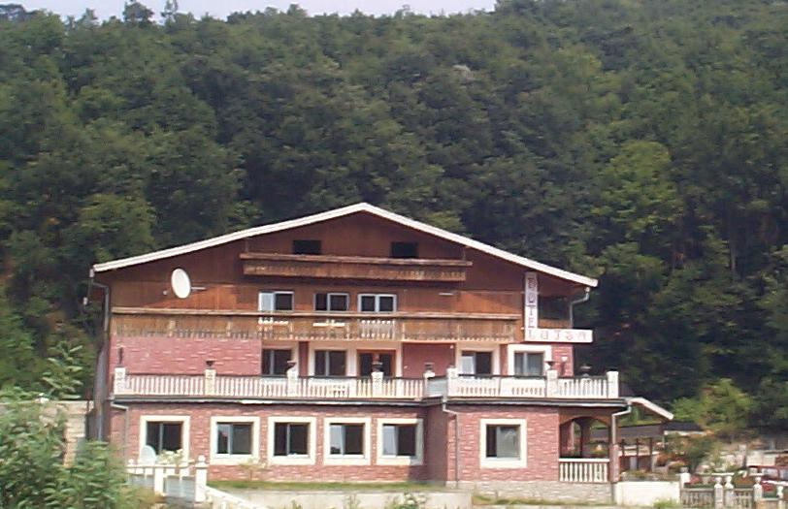
LUIZA Hotel
(Radimna)

Access: at the left from national road, at the foot of Piatra Alba (White Stone) Hill, coming from Oravita City.
Tourism offer: 20 accommodation places, parking, camping, bar, restaurant with terrace, Banat traditional menu from Valea Almajului (Almaj Valley) area, folk show including sings and dances from Danube Gorges area

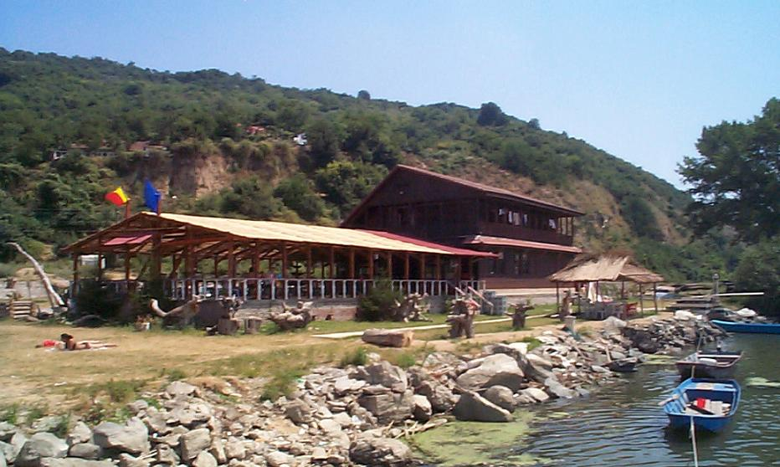
APUS DE SOARE Tourism Guesthouse
(Baziaş)
♣
Access: at the left from national road, at the enter in Bazias village, coming from Pojejena.
Tourism offer: 17 accommodation places, parking, camping, bar, restaurant with terrace, traditional fish menu, beech of lie in the sun on the Danube bank, ridings on the Danube by boat.

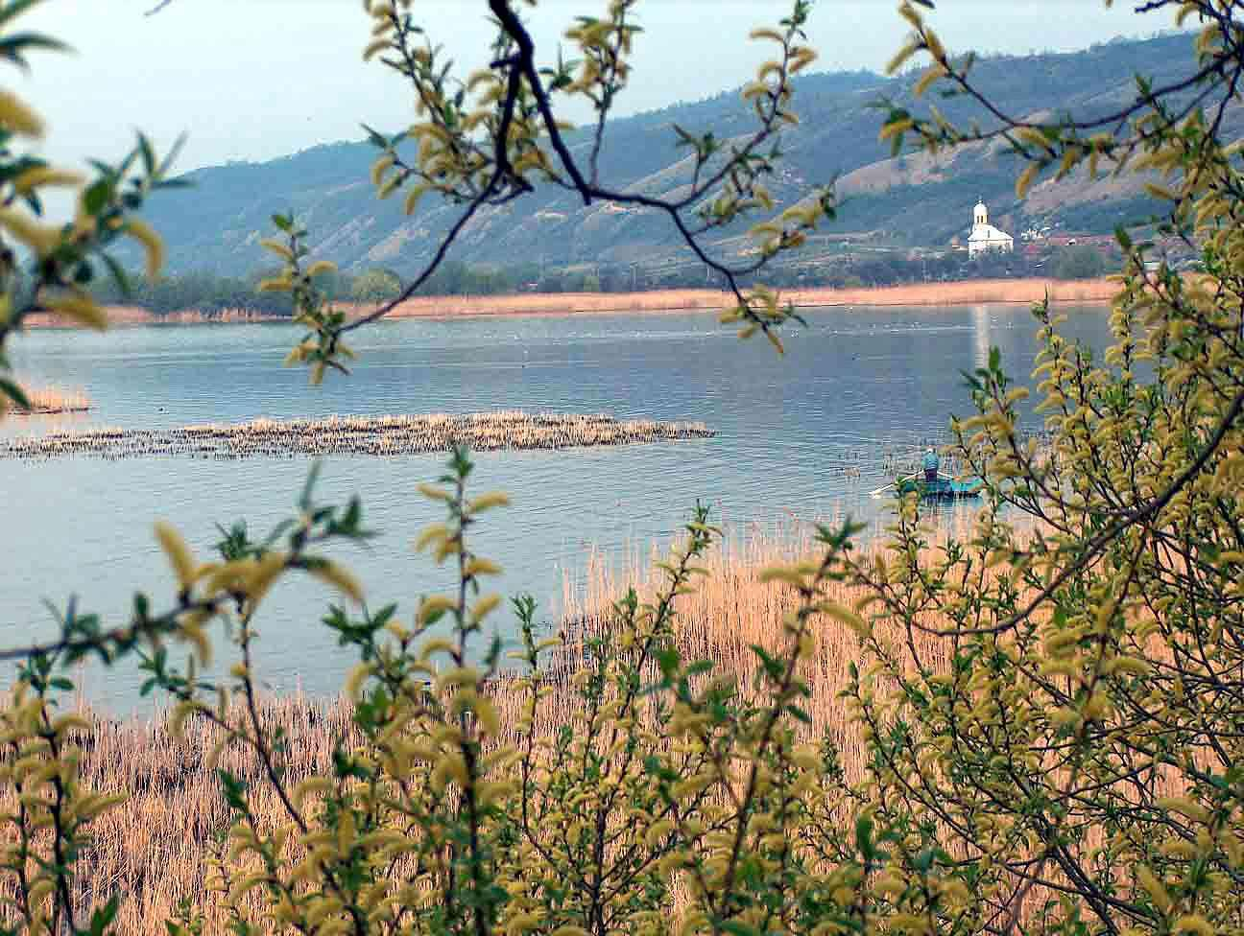
12, 00 – 14, 00
Zona umedă Divici - Pojejena
Rambling along the Danube River. Riding a bike (or by bus) on the run, at lengthwise of 14 Km on the dump areas placed on the territory of Pojejena commune.
Objectives
-Tour of the natural reserve Divici – Pojejena, Calinovat Island, and Rapa cu Lastuni - Valea Divici (swallow’s precipice of Divici Valley) included in Iron Gates National Park.
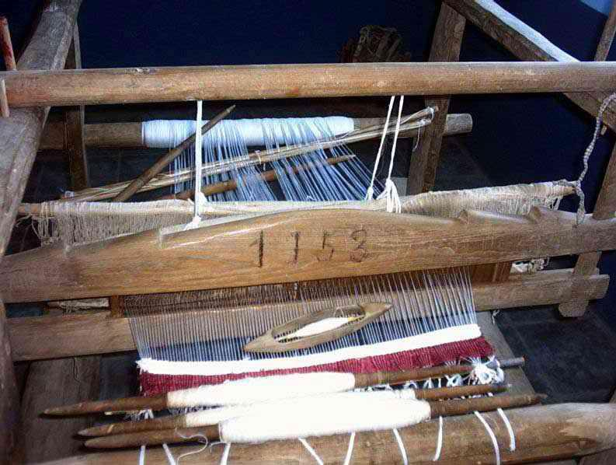
-Identifying and presentation of fauna exemplars of the protected species such as: raţă roşie, egretă mică, cormoran mic, silvia cu capul negru, lopătar
Muzeul etnografic Belobreşca
război de ţesut
- Local cultural historic objectives such as: Ruins of Divici Dac fortress, Pojejena carnival (Fashanck) in February, Pojejena Matcalau – an old Romanian custom in February, Pojejena sheep’s holiday in May; Belobresca grape ball in September, Belobresca puppet holiday in August, Pojejena village nedeea in May, Belbresca village nedeea in June, Belobreşca ethnographic museum.

14,00 – 15,00

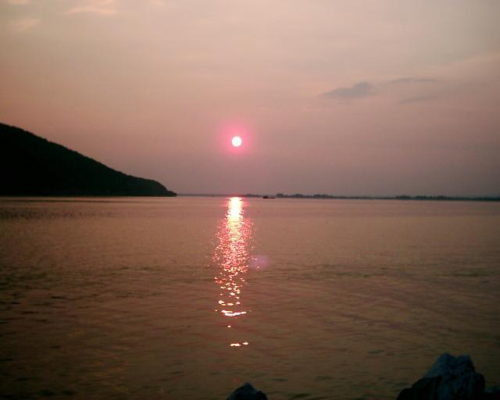
Breakfast at the accommodation places from IGNP area
Apus de soare la Baziaş

15,00 – 18,00
Baziaş – once a great village, now just a memory.
Objectives
- Identifying and presentation of fauna exemplars of the protected species from forest nature reserve Bazias such as: Fraxinus ornus, Cornus mas, Tilia tomentosa, Quercus cerris, Paeonia officinalis var. Banatica.
- Local cultural historic objectives such as: Saint Sava monastery; ruins of rail station, ruins of old Bazias Hotel and ruins of the oldest Romanian rail way, Socol village nedeea and Campia village nedeea in August 2th, Bazias village nedeea, in August 19th, Carnival (Fashanck) at Socol, Campia, Zlatita in February or Mart.

18,00 – 20,00
Rowing in the boat on the Danube at the sunset.
Objectives
Riding on the Danube by the boat with oars before the sunset in the Bazias village area; immortalizing (filming, photographing) of the sunset as an emblematic image of West Danube Gorges.

20,30

At this time a delicious fish menu diner will be served on the Danube bank, in the Bazias village area, accompanied by the tambourine murmur of Serb folk music

Sixth day’s Schedule

At the river junction of Nera with Danube

8,30 – 9,30

Breakfast at the accommodation places from IGNP area
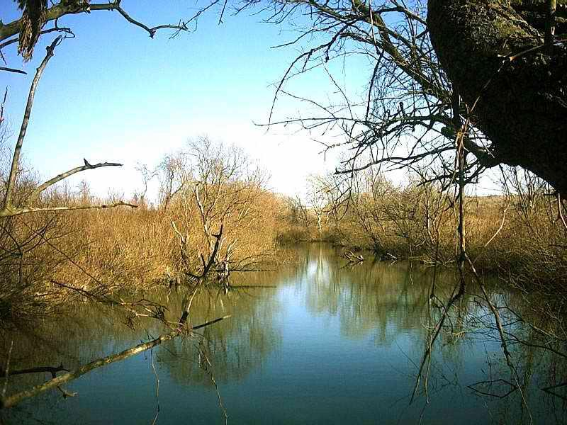
Braţul Nera Moartă
10,00 – 13,00
Land of mysteries from Nera Delta nature reserve. Walking on the tourism path, on the distance of 4 Km.
Objectives:
-Identifying and presentation of the protected species of flora and fauna such as: Typha sp., Phragmites sp., Carex sp., Salix sp., Egretta garzetta, Phalacrocorax pygmaeus, Lutra lutra)

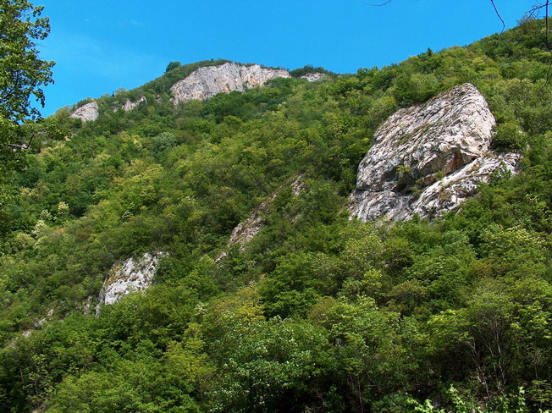
13,30 –15,00
Rezervaţia Valea Mare
At this time will take place a great lunch in Socol village including Serb traditional menu such as: Cheese pie, pumpkin pie, beam pudding, pancakes, fowl giblets stew, mulberry brandy.

15,00 – 16,00
Riding a bike (or by bus) at lengthwise of 25, on the run Socol – Moldova Noua

16,00 –19,00
In Valea Mare (Big Valley) nature reserve. This is another great experience that our tourists will come across. Travel by the cocheea (wagon drawn by horses) on a rural road, no rehabilitated, at lenghtwise of 6 Km, having max. Slope of 35%
Objectives
-Identifying and presentation of fauna exemplars of the protected species such as: iederă mare, fag, tei argintiu, tei pucios, ghimpe, liliac, scumpie, mojdrean, vişin turcesc, garofiţe, endemisme carpatice
- A small trip to Gura Haiduceasca (Outlaws) Cavern, Avenul Rosu (Red Cavern) will revel to the tourists the mountain peasant’s small farms (salash).

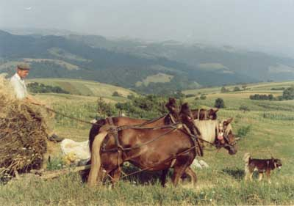
19,00 – 20,30
Cocia de la sălaşe
Diner will take place at the salash, and will introduce our guests to the Banat’s traditional menu from Almaj Mountain Range: gaigana (omelet including eggs, dray sausage, sheep cheese), corn bred; plum brandy (tzuica), apple juice, elder juice

20,30 – 22,00
This time our guests will return from natural heritage Valea Mare by cocheea (as optionally the tourists can sleep at salashes in the hayricks)

Seventh day’s schedule

From Coronini to Berzasca
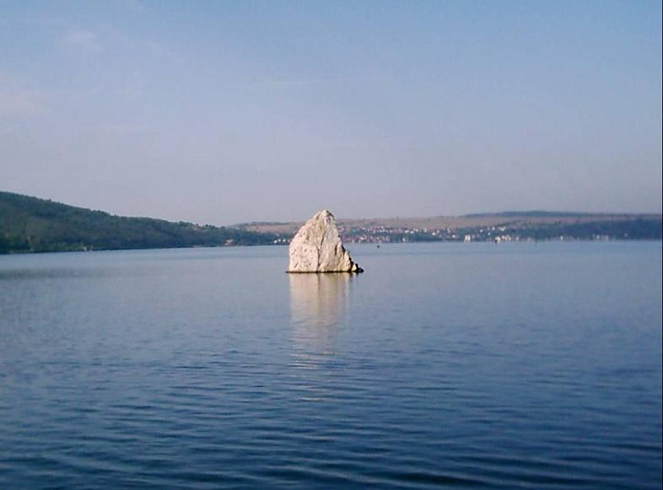
Stânca Babacai
crăiasa tăcută a Dunării

8,30 – 9,30

Breakfast at the accommodation places from IGNP area

10,00 – 12,00
Our guests will be visiting the wonderfull villages placed on Danube bank area. Riding a bike (or by bus) at lenghtwise of 30 Km on the run of Moldova Noua - Berzasca
Objectives
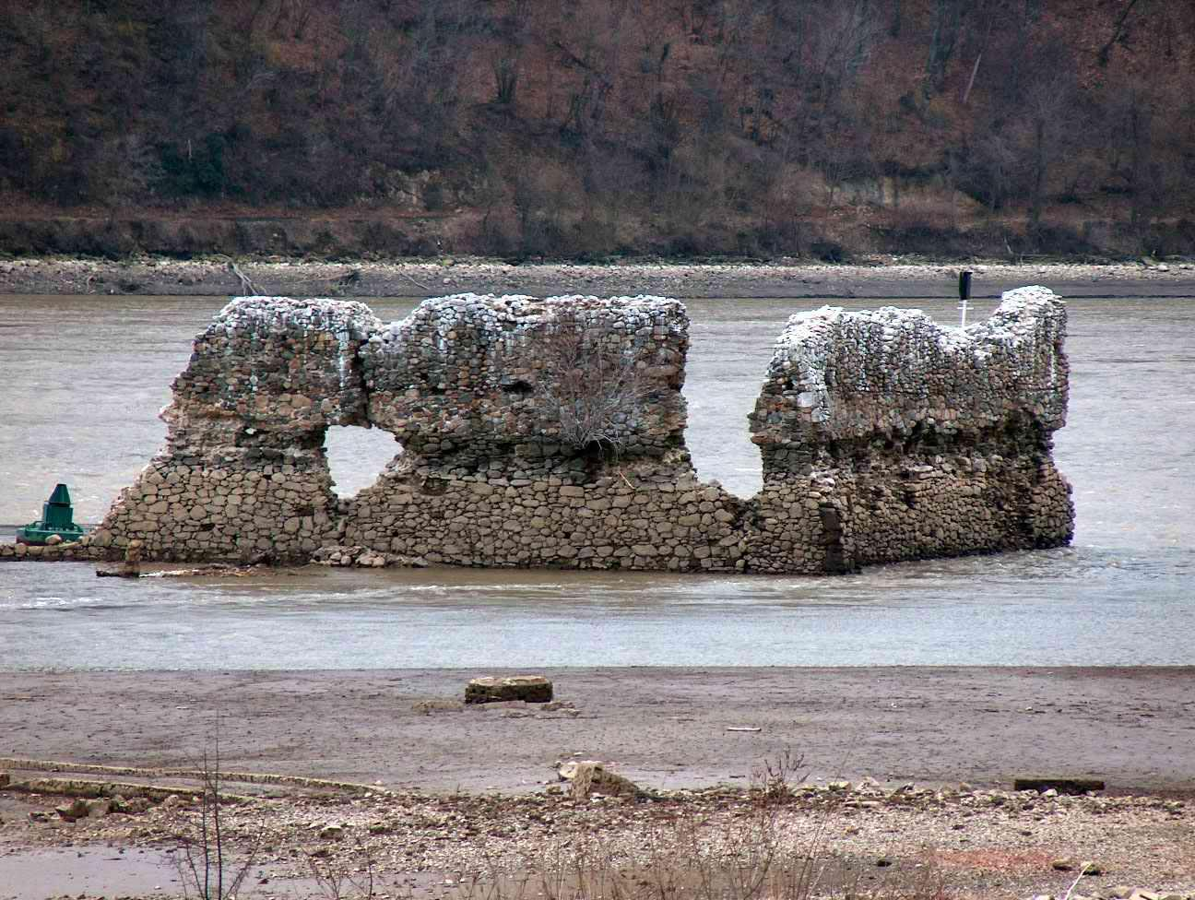
This is a the time dedicated to history lessons. Our guests will be impress by far with the ruins of Ladislau and Golubat fortresses, ruins of Sichevita Roman fortress, ruins of Drencova fortress. Here will also take place Coronini village nedeea in July 20th , Coronini Fashanck in February, Sichevita village nedeea in June, Sichevita Fashanck and Mask Festival in February, Gornea where our guest will be introduced to our national folklor. Nevertheless, the Village’s museum is another great touristic point were our guest can spend some time. Berzasca ecological informing center of Iron Gate Natural Park, Berzasca old orthodox church, Berzasca village nedeea of May 13th – 14^{th,} Bigar folk festival of Danube Gorges minorities in August, wood mills on Liubcova river, Gornea ethnographic museum are other places and events that just cannot be missed during this trip.
Ruinele cetăţii Drencova
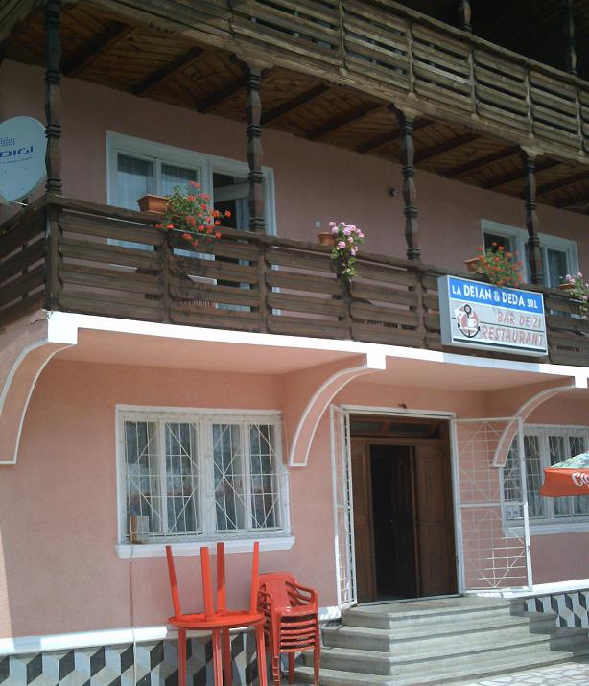
12,00 – 13,00
At this time accommodation and refreshment at the locations from the area of Berzasca Village will take place
‚

DEJAN & DEDA Tourism Guesthouse
(Gornea)
♣
Access: Make a left on national road coming from Berzasca, once you exit from Gornea village,
Tourism offer: 17 accommodation places, parking, bar, restaurant with terrace, traditional fish menu.

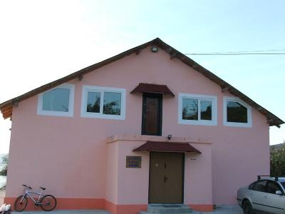
IZABELA Tourism Guesthouse
(Berzasca)
♣♣
Access: Make a right from the national road, after you enter in Berzasca Village coming from Moldova Noua City.
Tourism offer: 25 accommodation places, parking, bar, restaurant with terrace, traditional fish menu, folk show including sings and dances from Danube Gorges area

13,00 – 14,00
Lunch at the accommodation places from the area of Berzasca Village will take place now.

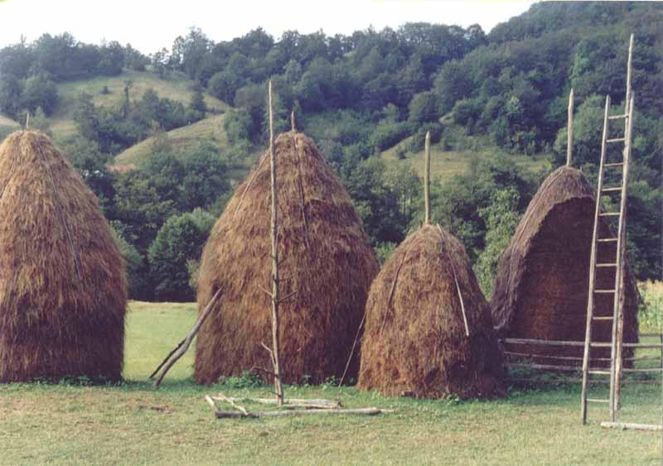
14,00 –18,30
Claia (căpiţa) de la sălaş ... patul
din Clisură al călătorului
This trip will take place again by cocheea in the Valea Berzasca (Berzasca Valey) area. What a great experience!
Objectives
- Travel by the cocheea on the rural road, no rehabilitated on the distance of 7 Km having max. slope of 30%
- Virgin forest including East beech, alder, Danube Gorges wild lilac, Turkish hazel tree, ash tree, fir tree,
- Forest fruits such as: blackberry, wild strawberry, nut raspberry
- Salashes and belvedere point Cracul Boului (Ox Pick)

19, 00 – 20, 30
Another great experience is waiting for you: Diner at the salash including an another Banat traditional menu from Almaj Mountain Range: mamaliga (corn pudding), sarmale (sauerkraut leafs filed with mince of smoked pork meat), tzuica, apple juice

20, 30 – 22, 00
Our guests will return from their trip by cocheea from Valea Berzasca (as optionally the tourists can sleep at salashes in the hayricks)

Good by to mirific world of Danube – Nera – Caraş micro region

8,30 – 9,30
Breakfast at the accommodation places from the area of Berzasca Village
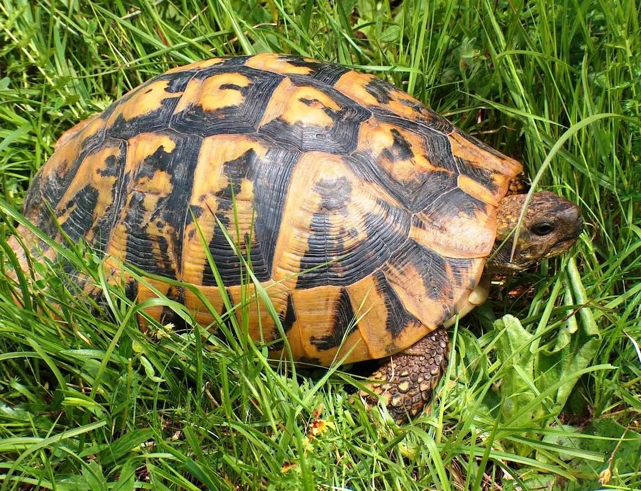
Ţestoasa lui Hermann

10,30 – 11,30
Did you like in Danube – Nera – Caras MICR region area
At this time an interactive evaluation of the ecotourism program will take place. On this activity the tourist group of Berzasca’s Ecological Informing Center will be involved too. We are really eager to hear your feedback. There will take place a quiz with fun prices testing our guests’s knowledge about this trip.

Orele 12,00 – 13,30
At this time will be served a lunch at the accommodation places from the area of Berzasca Village. Departure of tourism group will be following after that.

From Moldova Noua city till Resita, Timisoara or Orsova, the tourists can travel, starting at 14:00 o’clock, by the bus. In same time, from Moldova Nouă till Orsova the tourists can travel by the steam.

From Moldova Nouă till Veliko Gradiste, the tourists from Serbia can travel by the ferry bout, starting at15:00 o’clock.
Once again we want to assure our guests that this is a very enjoyable trip where they will come across great places and will gain lots of knowledge about this great part of the world. Our team is really well prepare to make you feel as comfortable as you need while you are spending your vacation with us. We hope we will see you soon.

Price of ecotourism program

You can participate on this great vacantion for only:
270 Euro – for full program including accommodation at the hotels or tourism guesthouses
130 Euro – for full program, including accommodation in the own tent

